[ Insert official UPAEP logo ]
UPAEP · Decanato de Ingenierías
EVIDENCE — US06-T1
Design the IoT-to-cloud data flow and message format
SmartGreenAI: Cilantro Crop

1. Task information
Task ID | US06-T1
User Story | US-06 — Transmit IoT measurements to the cloud
Sprint | Sprint 2 (2026-09-21 – 2026-10-09)
Week | Week 1
Responsible | Vicente Rocha Alfaro
Peer reviewer | Oscar Abraham Talavera Nava
Planned / actual hours | 3 h / 3 h
Completed on | September 25, 2026
Status | Done

2. Task description
Draw the flow: sensor, microcontroller, protocol (MQTT or HTTPS), cloud ingestion endpoint, database. Define the JSON payload (device_id, sensor_id, value, unit, timestamp in UTC) and the sending interval (e.g., every 60 s). Validate the payload with Carlos (US-08).

3. Completion conditions
✓ Condition 1: Flow diagram shows every component from sensor to database.
How it was verified: The diagram shows every component from the sensor to the database: the probes of GH-01/AREA-1, the ESP32 node with its NTP clock and local buffer, the HTTPS transport with the device API key, the ingestion endpoint of the API and the measurements table. The simulator uses the same path when the hardware is not connected.
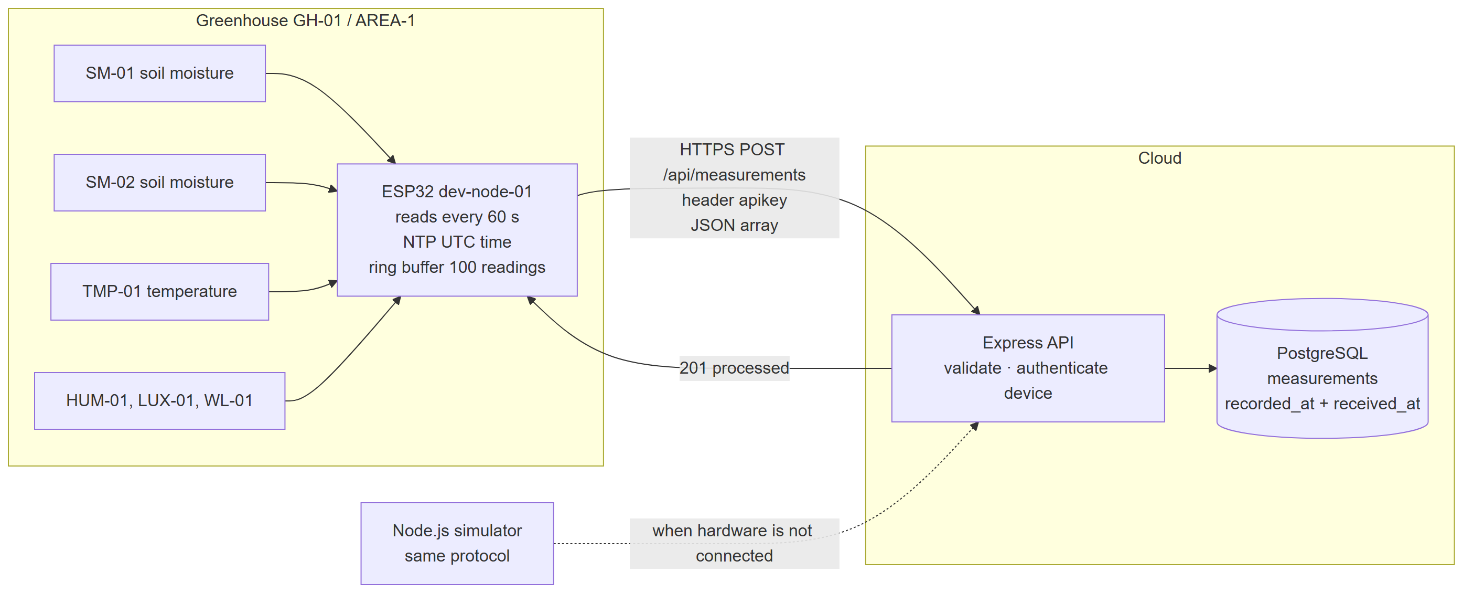
Figure US06-T1-1. IoT-to-cloud data flow: sensors → ESP32 → HTTPS → ingestion endpoint → database (Mermaid source in tools/evidence/diagrams/iot_to_cloud_flow.mmd). (US06-T1_Design_IoT-To-Cloud_Data_Flow_Message_1.png)
✓ Condition 2: JSON payload defines device_id, sensor_id, value, unit and UTC timestamp.
How it was verified: The payload defines device_id, sensor_id, value, unit and recorded_at (UTC, ISO 8601 with the Z suffix). device_id is checked against the device authenticated by the API key; the server adds received_at. The example below was sent to the real endpoint and accepted.
Payload fields
Field | Type | Example | Rule
device_id | string | dev-node-01 | must be the device of the sensor and of the API key
sensor_id | string | SM-01 | registered and active sensor
value | number | 66.4 | finite number
unit | string | % | unit of the sensor (%, C, lux, ppm, pH)
recorded_at | string | 2026-09-29T04:17:43Z | ISO 8601 UTC from the device clock (NTP); not more than 5 min in the future
1600,1100,2800,3860
Payload example accepted by POST /api/measurements (attached: US06-T1_Design_IoT-To-Cloud_Data_Flow_Message_2.txt)
POST /api/measurements
apikey: sec_io…
{
"device_id": "dev-node-01",
"sensor_id": "SM-01",
"value": 66.4,
"unit": "%",
"recorded_at": "2026-09-29T04:17:43Z"
}
→ HTTP 201 Created (24 ms)
{
"id": "msr-5516b4b1accb",
"sensor_id": "SM-01",
"status": "processed",
"inserted_at": "2026-09-29T04:17:43.206Z",
"alert": null,
"anomalies": []
}

✓ Condition 3: Payload and sending interval approved by Carlos (US-08) and the team.
How it was verified: Sending interval: one reading of every sensor each 60 seconds (READING_INTERVAL_MS = 60000 in the firmware; --interval 60 by default in the simulator), readings grouped in one array per cycle. The payload is the one of the API specification written by Carlos (US08-T1, POST /measurements) plus the device_id requested by this task, which the API validates.
iot/esp32_smartgreen/esp32_smartgreen.ino — lines 57–60
const unsigned long READING_INTERVAL_MS = 60000;
const unsigned long POLL_INTERVAL_MS = 5000;
const unsigned long HEARTBEAT_MS = 30000;

✓ Condition 4: Evidence: Flow diagram and payload example approved by the team.
How it was verified: The flow diagram (Figure 1) and the payload example above were approved by the team (see the approval record).

4. Attached files
- US06-T1_Design_IoT-To-Cloud_Data_Flow_Message_1.png
- US06-T1_Design_IoT-To-Cloud_Data_Flow_Message_2.txt

5. Traceability
Related requirements | FR-05, FR-24, NFR-05, NFR-08, NFR-09
Implementation | See docs/TRACEABILITY.md
Verification | See docs/TRACEABILITY.md

6. Sign-off
Role | Name | Date | Signature
Responsible | Vicente Rocha Alfaro | September 25, 2026
Peer reviewer | Oscar Abraham Talavera Nava | September 25, 2026
Product Owner acceptance | Alexis Enrique Valle Parra | September 25, 2026
Approval record: Daily Meeting 2 of Sprint 2 (Monday, September 28, 2026): "Review of the Week 1 milestone: US-01-C closed, API specification (US08-T1) shared on Wednesday, ER diagram and payload format approved." Decision: the firmware obtains UTC by NTP and sends recorded_at in ISO 8601; the server also stores received_at.

